**RideHive Application Screenshots**

**Home Page –**

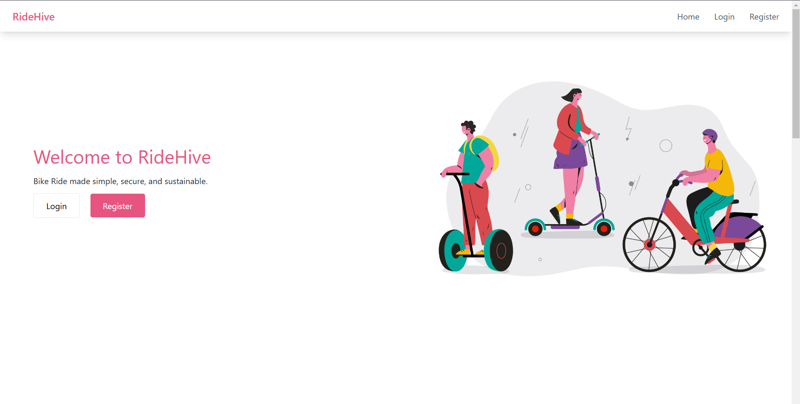

**Login –**

**Register -**

**User Dashboard -**

**User Book -**

**User Book Form -**

**User Payment Form -**

**User booking confirmation -**

**User Booking History -**

**User Reservations -**

**Vendor Vehicle Management -**

**Vendor Reservations -**

**Vendor Booking History -**

**Admin Manage Users -**

**Admin Manage Vendors -**

**Admin Vehicle Approval -**

**Admin Transaction History -**

